# Project Report: CI/CD Pipeline with GitHub Actions & Docker

**Project:** Project 4: CI/CD Pipeline with GitHub Actions & Docker

**Author:** Mazin

**1. Introduction**

The objective of this project was to establish a fundamental Continuous Integration and Continuous Deployment (CI/CD) pipeline for a containerized application [cite: devops projects.pdf]. Modern software development relies heavily on automation to ensure code quality, consistent builds, and faster deployments. This project demonstrates the core principles of CI/CD using industry-standard tools like Docker for containerization, GitHub Actions for automation, and Minikube for simulating a deployment environment.

**2. Abstract**

This project successfully created a full CI/CD pipeline for a simple Python Flask web application. The application code and associated tests were developed and stored in a GitHub repository. A Dockerfile was written to containerize the application, packaging it with all its dependencies. A GitHub Actions workflow was configured to automatically trigger on code pushes to the main branch. This workflow first runs automated tests (pytest); if they pass, it builds the Docker image and pushes the tagged image to Docker Hub. Finally, Kubernetes configuration files (deployment.yml, service.yml) were created to deploy and expose the containerized application locally using Minikube, simulating a real-world deployment process.

**3. Tools Used**

* **Python:** Programming language used for the web application.
* **Flask:** Micro web framework for Python used to build the simple web server.
* **pytest:** Framework used for writing and running automated tests for the Python application.
* **Docker:** Platform used to containerize the application, ensuring consistency across environments.
* **Docker Hub:** Cloud-based registry service used to store and distribute the built Docker images.
* **GitHub Actions:** CI/CD platform used to automate the testing, building, and pushing of the Docker image.
* **Minikube:** Tool used to run a local Kubernetes cluster for testing deployment configurations.
* **kubectl:** Command-line tool used to interact with the Kubernetes cluster (Minikube).
* **Git:** Version control system used to manage the source code.

**4. Steps Involved in Building the Project**

The pipeline was constructed and validated through the following sequence:

**Step 1: Application Development and Testing**

A simple Flask web application (app.py) was created to serve a "Hello World" message. Dependencies (Flask, pytest) were listed in requirements.txt. An automated test (app_test.py) was written using pytest to verify the application's basic functionality.

**Step 2: Containerization with Docker**

A Dockerfile was created in the project directory. This file defined the steps to build a container image based on the official Python 3.10 slim image, install dependencies, copy the application code, expose the necessary port, and set the command to run the Flask application.

The image was built locally using docker build -t my-python-app . and tested successfully using docker run -p 5000:5000 my-python-app, verifying accessibility via http://localhost:5000.

**Step 3: CI Pipeline Setup with GitHub Actions**

A workflow file (.github/workflows/project-4-docker-ci-workflow.yml) was created. This workflow configured:

* **Trigger:** On push to the main/master branch, specifically for changes within the project's subfolder.
* **Testing:** Automated execution of pytest after installing dependencies.
* **Docker Hub Login:** Secure login using DOCKER_USERNAME and DOCKER_PASSWORD stored as GitHub secrets.
* **Build & Push:** Building the Docker image using the Dockerfile and pushing it to Docker Hub, tagged with the repository name (e.g., mazinmazy/devops-internship-elavate-labs:latest).

**Step 4: CI Pipeline Validation**

Code changes were pushed to the GitHub repository, triggering the workflow. The workflow executed successfully, passing the tests and pushing the image to Docker Hub.

**Step 5: Local Deployment Configuration (Kubernetes)**

Two YAML files were created for Minikube:

* **deployment.yml:** Defined a Kubernetes Deployment to run two replicas of the application, pulling the correct image (mazinmazy/devops-internship-elavate-labs:latest) from Docker Hub.
* **service.yml:** Defined a Kubernetes Service of type NodePort to expose the Deployment externally, mapping traffic to the container's port 5000.

**Step 6: Deployment Validation with Minikube**

Minikube was started (minikube start). The Kubernetes configurations were applied using kubectl apply -f deployment.yml and kubectl apply -f service.yml. The status of the pods was checked using kubectl get pods, confirming they reached the Running state.

Finally, the application was accessed using minikube service python-app-service, which successfully opened the running application in the browser.

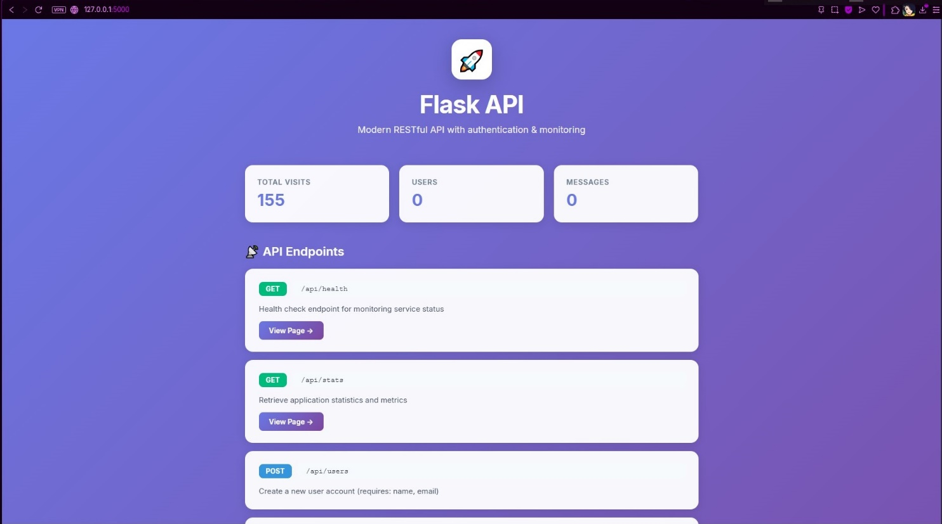

**5. Conclusion**

This project successfully demonstrated the creation of a complete CI/CD pipeline for a containerized application. It covered key DevOps practices including automated testing, containerization with Docker, automated image building and pushing with GitHub Actions, and deployment orchestration using Kubernetes (simulated locally with Minikube). The pipeline ensures that code changes are automatically tested and packaged, ready for deployment, significantly improving the reliability and speed of the development lifecycle. This foundational setup can be extended for more complex applications and deployment strategies.